Samsung SSD 980 PCIe Gen3x4 NVMe M.2 1TB 2280 | MZ-V8V1T0BW

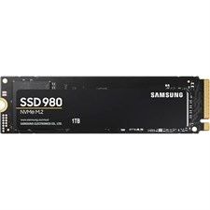

**Key Specifications**

* Capacity: 1TB
* Interface: PCIe Gen 3.0 x4, NVMe 1.4
* Form Factor: M.2 2280
* Sequential Read Speed: Up to 3,500 MB/s
* Sequential Write Speed: Up to 3,000 MB/s

**Compatibility and Ease of Use**

* M.2 Slot Compatibility:  
  Works seamlessly with devices that have an M.2 PCIe slot.
* Samsung Magician Software:  
  Allows users to monitor performance, update firmware, and optimize the SSD easily.

**Warranty**

* Backed by a **5-year limited warranty**, ensuring peace of mind and customer support.

**Advanced Technology**

* **Samsung Controller**:  
  Custom-designed to optimize the balance between performance, power consumption, and reliability.